[Outage Start] – Use convert text to column wizard to generate the dates

Format - Short date

Remove repetitive outages (same date, same feed) – 81 counts in 2014

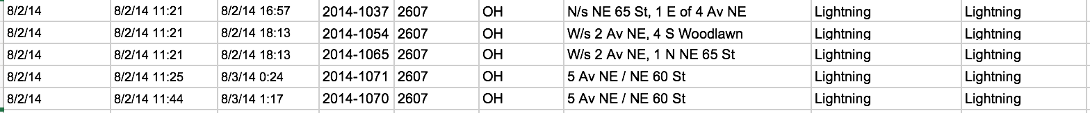

Filter

[Category] – only by equipment or natural causes

Bird/Animal

Equipment Failure

Fire

Lightening

Other

Trees/Wire down

[Outage Type] – remove others which won’t affect customers

OH

UG

[Cause] –deselect

balloon

no cause found

vandalism

Copy filtered results to a new worksheet

Use countif and countifs to count the number of incidences

Consolidate into the weather file